MFANZ Interface Control System:

Installation

Last Saved: 16/09/2008 04:52:00 AM

Table Of Contents
1 Table Of Contents 2
2 Document Purpose 3
3 Definitions 3
4 Background 3
5 Component Installation 3
5.1 Unix Scripts 3
5.1.1 Configuration 3
5.1.2 Directory Structure 4
5.1.3 Script and Configuration files 4
5.2 Database 4
5.2.1 LICS Schemas 5
5.2.2 LICS Compilation 5
5.2.3 LICS_APP Compilation 5
5.2.4 Configuration 6
5.3 Webpage 6
5.3.1 Dynamic Link Libraries (DLLs) 7
5.3.2 ICS Files 7
6 Appendix 8
6.1 Example Work Orders 8
6.1.1 LICS Schema Creation 8
6.1.2 LICS Schema Compilation 9
6.1.3 ICS Webpage 10

Document Purpose

Provide a step-by-step guide to the installation of the Interface Control System (ICS) components and the configuration options available. Each environment is different, so any environment-dependant areas will be highlighted as necessary.

Definitions

Name | Definition
PTR | Path To Repository – the local path on your computer to the TortoiseSVN repository. Eg: c:\work
ICS | Interface Control System
LICS | Local Interface Control System

Background

ICS has been running under multiple environments for a number of years. It encapsulates the complexity of the data interface functionality in a single place and to provide a central point of reference for support issues. ICS itself contains multiple components to allow it to carry out the tasks it is designed for. There are database components, webpage components and also Unix components that have to be installed for ICS to run as designed.

Component Installation

Unix Scripts

The Unix scripts are responsible for managing the files that are inbound and outbound to the server. The script to use can be defined in the interface configuration on the ICS webpage, depending on the interface being used. The transfer type will decide which script to use for an interface.

Configuration

If the Unix server ICS is being installed onto does not have a previous installation of ICS on it, you will need to setup the ICS user account and file system. A work order will need to be created to get the ICS user and file system added to the Unix system, and it is always good to include a similar Unix system with ICS installed already as a template. So the configuration should include:

- Creation of an ICS user
- Creation of an ICS file system
- Add the ICS user to the MQM group
- Ensure the Oracle user is also part of the MQM group

The WO should be forwarded to the UNIX magic group.

Directory Structure

The directory structure is similar for each ICS installation. Create a new directory in the ics root (such as lad), and then create another directory based on the environment (test or prod). The following directories should then be added:

- archive – processed inbound/outbound files
- bin – scripts for processing inbound and outbound interfaces
- config – configuration files for the environment the interfaces are being processed for
- inbound – inbound files to be processed
- java – directory used by Oracle
- log – log files for the current day
- outbound – outbound files to be processed
- statistics – directory used by Oracle
- temp – folder for placing temp files. Not used by scripts, but can be useful for testing/debugging purposes
- webview – temporary location for files being viewed through the ICS webpage
- work – temporary location for files being used by an interface being processed
- log/archive – archive of log files from previous days

Script and Configuration files

The script files are standard across all ICS installations. They are located in the following directory:

<PTR>\Regional\SOURCE\LICS\BASE\UNIX

Copy all files from that directory in the bin directory on the server.

The configuration file, ics_loader.config, is unique for each environment. Create a new entry in the repository for the application, and then have a folder for the test and production environments. Use an existing configuration file to create the new one from, as the only real differences are usually for the database and logins. Upload the configuration file into the config directory.

Finally run the following command in the log directory:

touch ics_integration.log

Ensure all files (script and configuration) are set to have full read and write permissions set. This can be done using the following command:

chmod 777 <filename(s)>

Database

The database requires the creation of the LICS (Local Interface Control System) and LICS_APP schemas. These schemas provide the framework for processing interface files between upstream and downstream systems. The database ICS is being installed on must be UTF-8. Check with the DBA’s to confirm this.

The files for the objects within LICS and LICS_APP are located in the following directory:

<PTR>\Regional\SOURCE\LICS\BASE\ORACLE

LICS Schemas

Create a WO to create the LICS and LICS_APP schemas on the database. Provide the following details in the WO:

- Size of LICS schema. Usually 1gb is enough. If the database is going to have a high frequency of traffic (such as AP0064P) you will need to increase the size.
- Password for LICS_APP schema
- If a test database you may give a password for LICS also. Not required.

LICS Compilation

The compilation of the LICS schema is run from the _lics_build.sql file on SQLPlus. The following work variables need to be modified for the environment you are installing under:

- tab_path
- sql_path
- database
- data_password

Add all the files in the lics folder into a compressed file, apart from the excluded files below. Also include the _lics_build.sql file in the compressed file.

Excluded files:
- _lics_synonym.txt

If the installation is for a production environment, the compressed file must be sent to the DBA’s and create a WO for the data to be compiled. Under a test environment you can run it yourself using SQLPlus, assuming you have the LICS password. Extract the compressed file to a temporary directory, then open SQLPlus and run the following command:

@<path_to_files>\_lics_build.sql

Note: there is a limit to the length of the files in SQLPlus. Ensure the length of the path_to_files isn’t over 40 characters.

Once the installation is completed, add the build script to the source repository for future reference. Existing install scripts can be located in the following directory:

<PTR>\Regional\SOURCE\LICS\BASE\ORACLE\INSTALL

LICS_APP Compilation

The compilation of the LICS_APP schema is run from the _lics_app_build.sql file on SQLPlus. The following work variables need to be modified for the environment you are installing under:

- pro_path
- sql_path
- database
- code_password

The LICS_APP schema also includes a parameter file (lics_parameter.sql) that is configured for each environment. Ensure the parameter file is set correctly before running the script. The following areas need to be set correctly:

- system parameters
- path to unix scripts

Firstly you need to get the DBA’s to run the code in the ics_database_setup.sql file (in the install folder). Set the path, and check the database version. If the database is 9i, then change the DBEC to IU_APP. There are cases where the LICS_APP schema will lack permissions to create a type object. Speak to the DBA’s to get this access before running the script. The files that create a type object are:

- lics_security
- lics_spreadsheet
- lics_datastore

The installation of the objects into LICS_APP can be done by our team, regardless of whether it is a test or production environment. Connect to the database using SQLPlus and run the following command:

@<path_to_files>\_lics_app_build.sql

Finally check with the DBA’s to ensure the database has the job queue processes set to 100.

Note: there is a limit to the length of the files in SQLPlus. Ensure the length of the path_to_files isn’t over 40 characters.

Once the installation is completed, add the build script to the source repository for future reference. Do not commit any changes to the lics_parameter.sql file in the LICS_APP/CODE folder. Existing install scripts can be located in the following directory:

<PTR>\Regional\SOURCE\LICS\BASE\ORACLE\INSTALL

Note: during past installations in production there have been issues with the lics_outbound_loader. Please ensure that there is no existing lics_outbound_loader synonym for a database link to AP0064P. If there is, you will need to get the name changed to outbound_loader and ensure all packages that referenced lics_outbound_loader now call the new synonym (i.e. outbound_loader).

Configuration

To complete the LICS and LICS_APP installations you need to run the configure.sql file. You can use an existing file from the install folder of another environment, and make the required changes. Open the file and check that the data is relevant to the environment you’re installing on. For example, if the database isn’t a plant database, you wont need the LADPDB01 interface included in the installation! Also remember to set the work variables at the top of the file, and ensure the lics_sec_user contains the correct users.

Webpage

The ICS webpage gives the user a tool to manage the interfaces, jobs and security of the ICS installation for the environment. In production, the web infrastructure teams are responsible for installing the ICS webpage onto the required web server. In test, we can get the required access of Ivan Saric so we can get the webpage done ourselves.

Dynamic Link Libraries (DLLs)

The DLLs are only required if the web server does not already have an existing ICS installation. Create a WO to get the DLLs registered on the web server, and forward it to the WEB_INFRASTRUCTURE team. The DLLs are located in the following directory:

<PTR>\Regional\SOURCE\LICS\BASE\MICROSOFT\VB\bin

Once the DLLs have been registered you can install the ICS webpage.

ICS Files

The ICS files can be installed anywhere in the root directory of the web server. If there is another webpage already on the web server, it is probably best to create a new directory and install the ICS files into it. The ICS files are located in the following directory:

<PTR>\Regional\SOURCE\LICS\BASE\MICROSOFT\ASP

You will need to create an ics_security.txt file, which contains the login details for the LICS_APP schema on the database ICS is being installed for. The normally contains the following:

<?xml version="1.0"?>
<!-- -->
<!-- MFANZ Interface Control System Security -->
<!-- -->
<security connectionString="Provider=MSDAORA;User Id=lics_app;Password=licsfexapp;Data Source=ap0085p.ap.mars;"></security>

The ics_std_code.inc file also needs to be modified for the environment it is running under. The following needs to be set:

- Environment
- Installation
- Character Set
- Ensure the GetUser function doesn’t return gregaste
- Set the correct path for the GetSecurity and GetSecurityCheck functions. You may need to request the web infrastructure team set this in the WO as only they will know it

Once the files have been configured, you can either create a WO to get the web infrastructure team to install the ICS files, or if you have access you can add them yourself. Connect to the web server using Microsoft Visual Studio, and drag/drop the files into the folder.

Finally, to allow the new site to be visible from the main ICS webpage, connect to webappdev11.ap.mars and add the site to the ics_browser.asp file.

Appendix

Example Work Orders

LICS Schema Creation

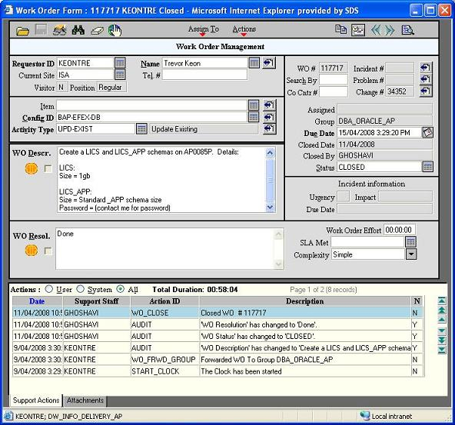

LICS Schema Compilation

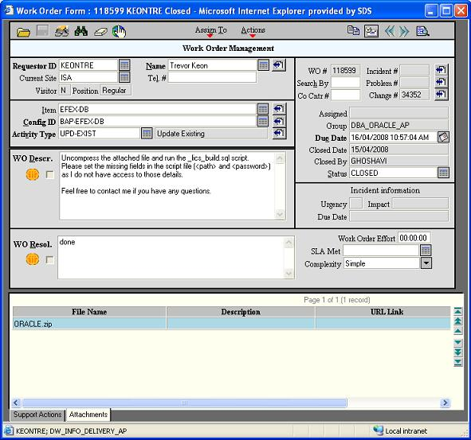

ICS Webpage

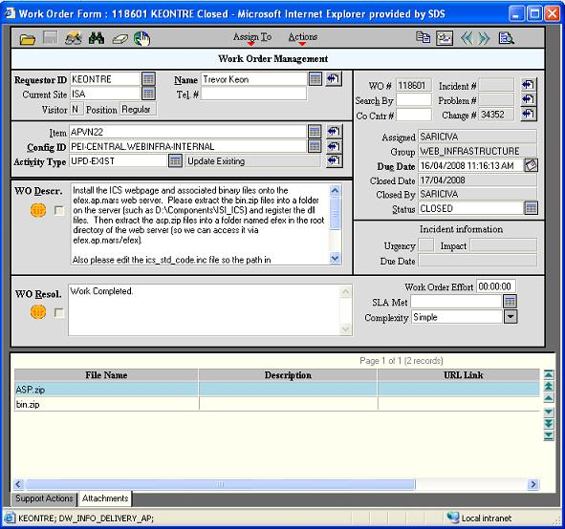

The WO Description is as follows:

Install the ICS webpage and associated binary files onto the efex.ap.mars web server. Please extract the bin.zip files into a folder on the server (such as D:\Components\ISI_ICS) and register the dll files. Then extract the asp.zip files into a folder named efex in the root directory of the web server (so we can access it via efex.ap.mars/efex).

Also please edit the ics_std_code.inc file so the path in the "GetSecurityCheck" function is set correctly for the ics_security.txt file.

I have run through a similar install with Ivan Saric on webappdev51.ap.mars, so contact him for any questions.

Appendix 6.1.1 – LICS Schema Creation
Appendix 6.1.2 – LICS Schema Compilation
Appendix 6.1.3 – ICS Webpage

